



[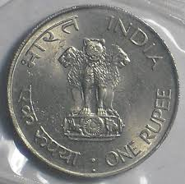](https://www.google.com/imgres?imgurl=http://4photos.net/photosv5/indian_rupees_coins_1342017456.jpg&imgrefurl=http://4photos.net/en/image:154-216831-Indian_Rupees_Coins_images&docid=43IgtHXkSNT_9M&tbnid=fGRdC9LiKgXYiM:&w=1450&h=1445&ei=wSOhVZqSEs6jyATFg5yIAg&ved=0CAIQxiAwAA&iact=c)India

$1 USD = 63.77 Indian Rupees

To earn respect while spending time in India it’s important to respect their culture. You will need to buy traditional Indian clothing. You bargain the price of fabric down to 385 Indian Rupees. You then have to have it tailored in which you pay 275 Indian Rupees.

How much USD did you spend?

[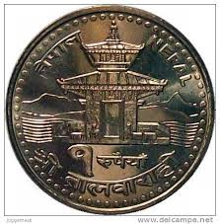](https://www.google.com/imgres?imgurl=http://images-01.delcampe-static.net/img_large/auction/000/317/090/481_001.jpg?v%3D1&imgrefurl=http://www.delcampe.net/items?language%3DE%26catLists%5b0%5d%3D1199%26sortByForm%5bsort%5d%3Dprice_present_ASC%26page%3D1%26useAsDefault%3DN&docid=PCUBjidITh1V_M&tbnid=5tlqdSGi6WxFYM:&w=501&h=510&ei=fiOhVZ_1BZesyASeyrrQDg&ved=0CAIQxiAwAA&iact=c)Nepal

$1 USD = 102.23 Nepalese Rupees

What’s traveling without trying different modes of transportation? Let’s ride an elephant at the base of the Himalayas! It cost $45 USD to ride the elephant, but you need to pay in Nepalese Rupees.

How many Nepalese Rupees will you pay?

[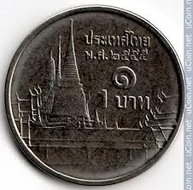](https://www.google.com/imgres?imgurl=http://i.ucoin.net/coin/192/1922/192272_1/thailand-1-baht-2012.jpg&imgrefurl=http://en.ucoin.net/coin/thailand-1-baht-2012/?cid%3D15096&docid=Vwda4ZyCGOmIjM&tbnid=Z5NIBA2Vb21MbM:&w=500&h=494&ei=RCOhVYy1CpGBygS1zqyoDQ&ved=0CAIQxiAwAA&iact=c)Thailand

$1 USD = 33.78 Thai Baht

You are only about a 4 ½ hour ride from a gorgeous seven-layer waterfall, but you have no car. You and 5 other friends decide to rent a van for the day to drive you there. It will cost a total of 6,000 Baht to rent the van.

How much USD will it cost each person to go to the seven-layer water fall?

[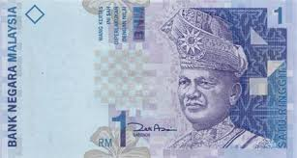](https://www.google.com/imgres?imgurl=http://flagpedia.net/data/currency/myr/1-malaysia-ringgit-front.jpg&imgrefurl=http://flagpedia.net/currency/others/malaysian-ringgit&docid=mTphn-FKpr6-UM&tbnid=yUN1bzdntJE-2M:&w=438&h=234&ei=HCOhVZWMNI2pyATp6oPwDA&ved=0CAIQxiAwAA&iact=c)Malaysia

$1 USD = 3.77 Malaysian Ringgit

You have a $4 budget for food for the day. You need to decide if you have enough money to in the restaurant or if you need to eat from a street vendor. Chicken and rice cost 5 Ringgit at the street vendor and 8 Ringgit at the restaurant.

1. How much USD do you save eating at the street vendor?
2. Do you think you would have enough money for the restaurant on a $4 a day budget?

[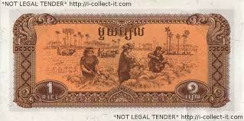](https://www.google.com/imgres?imgurl=http://stampscoinsnotes.com/images/paper%20money/Cambodia/Cambodia%201%20Riel%201979.alt.300dpi.jpg&imgrefurl=http://stampscoinsnotes.com/banknote/cambodia-1-riel-1979/&docid=lfXZE3G-ZLBY6M&tbnid=YbIyKwFd5eK2JM:&w=738&h=366&ei=7iKhVc6-Bc2VyATSp76QCg&ved=0CAIQxiAwAA&iact=c)Cambodia

$1 USD = 4,099.95 Cambodian Riel

Angkor Wat is a city of ancient ruins that date back to the year 805 A.D. and is the temple where Tomb Raider was filmed. It cost 74,925 Riel to see the ruins. In Cambodia, they use US dollar bills as currency, and any change is paid for in Riel.

If you pay with a 20 US dollar bill…

1. How many dollar bills will you get in change?
2. How much Riel will you get in change?

[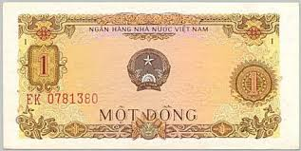](https://www.google.com/imgres?imgurl=http://www.vietnamtravels.vn/Vietnam-currency/1-cotton-front-1976.jpg&imgrefurl=http://vietnamtravels.vn/tours/services/1021/Vietnam-old-money,-notes,-coins.htm&docid=m1bm1fPufEDzLM&tbnid=thIt9pifv5C96M:&w=459&h=231&ei=sCKhVa6IBI-cyASp-L-IAQ&ved=0CAIQxiAwAA&iact=c)Vietnam

$1 USD = 21,817.50 Vietnamese Dong

A traditional and delicious Vietnamese meal is a soup called Pho. It cost about $0.75. A giant smoothie is also $0.75.

How much Vietnamese Dong do you need to buy both Pho and a smoothie for lunch?

[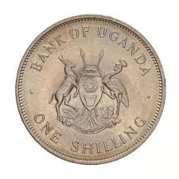](https://www.google.com/imgres?imgurl=http://museumvictoria.com.au/collections/itemimages/513/040/513040_Large.jpg&imgrefurl=http://museumvictoria.com.au/collections/items/1323342/coin-1-shilling-uganda-1968&docid=Pd585kH49ND1EM&tbnid=uH1WHL2mw-SRIM:&w=950&h=950&ei=fCKhVfvzPM-syASSqKLgDA&ved=0CAIQxiAwAA&iact=c)Uganda

$1 USD = 3,285 Ugandan Shillings

Hello adventure!

You have the chance to bungee jump over the Nile River for 310,000 Shillings and/or Raft the Nile for 200,000 Shillings. You’ve set a budget of $200.

Do you have enough money to both Bungee Jump and Raft the Nile?

[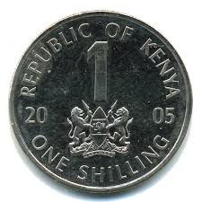](https://www.google.com/imgres?imgurl=http://www.e-allmoney.com/coins/afr/img/1ken1YRss.gif&imgrefurl=http://www.e-allmoney.com/coins/afr/kenya-c.html&docid=PY3NxBMboyNBcM&tbnid=XVIomZebOWXaNM:&w=624&h=624&ei=NyKhVfTbPNeuyATY8KTQCQ&ved=0CAIQxiAwAA&iact=c)Kenya

$1 USD = 98.64 Kenyan Shillings

To get the full cultural experience of Africa, you and your friends decide to take a Land Rover ride to a remote Masai Mara tribal village which is a 3 hour ride, into the Great Rift Valley, from the nearest town. It cost $60 for gas to drive one way.

How many Kenyan shillings would you need to pay for gas for a round trip?

[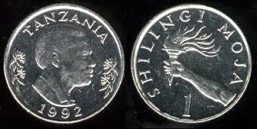](https://www.google.com/imgres?imgurl=http://www.studentsoftheworld.info/sites/country/img/20418_Currency1.jpg&imgrefurl=http://www.studentsoftheworld.info/sites/country/tanzania.php?Page%3D5&docid=6ovguifnvOOQNM&tbnid=eC0GSe3qfjLsvM:&w=392&h=197&ei=_CGhVY_BMo2zyATt-pyYAQ&ved=0CAIQxiAwAA&iact=c)Tanzania

$1 USD = 2,185.10 Tanzanian Shillings

*NATS INGONYAMA BAGITHI BABA!!!* (Lion King) Tanzania is home of the Serengeti. How could you pass up a chance to go on an authentic two-day safari where you get to camp in the middle of the reserve? It will cost $280, food included. Your driver needs the money in shillings.

How many shillings do you need to pay to go on the safari?

[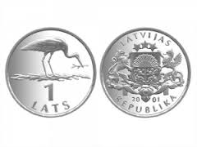](http://www.google.com/imgres?imgurl=http://cdn1.pri.org/sites/default/files/migration/PriMigrationsDamanticWordpressAttachmentsImagesMigration/www.theworld.org/wp-content/uploads/1-lat-circulation-coin-with-a-nesting-stork.-Stork-is-one-of-the-most-frequent-birds-in-Latvia.-Photo-The-Bank-of-Latvia.-e1360359292441.jpg&imgrefurl=http://www.pri.org/stories/2013-02-08/little-enthusiasm-latvias-euro-effort&h=225&w=300&tbnid=cgMv1pTSajKiNM:&zoom=1&docid=-hfUQq7gPqa_EM&ei=SyGhVbDFBseyogSLjoDAAw&tbm=isch&ved=0CGkQMyhFMEU)Latvia

$1 USD = 0.62 Latvian Lats

1kg = 2.2 lbs

To make dinner for you and your friends, you go to the local market. Your recipe is in pounds and calls for ½ lbs of cheese.

Cheese cost 15 Lats per kg.

How many Lats will it cost to buy the cheese for dinner?

[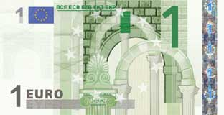](https://www.google.com/url?sa=i&rct=j&q=&esrc=s&source=images&cd=&cad=rja&uact=8&ved=0CAcQjRw&url=https://forum.eurobilltracker.com/viewtopic.php?f%3D7%26t%3D630%26start%3D90&ei=4yChVaCoHoeoyASUmp2YBg&bvm=bv.97653015,d.cGU&psig=AFQjCNEHNgV0ssUwJnMIrwfFkB0qW0M5UQ&ust=1436709469713793)Estonia

$1 USD = 0.89 Euros

Living in the historic capital of Tallinn, you will need to buy bus and trolley passes for you and your 5 friends. You will be in town for four weeks. Week long passes are $13 each.

How many Euros will it cost for all of you to get around the city for four weeks?

[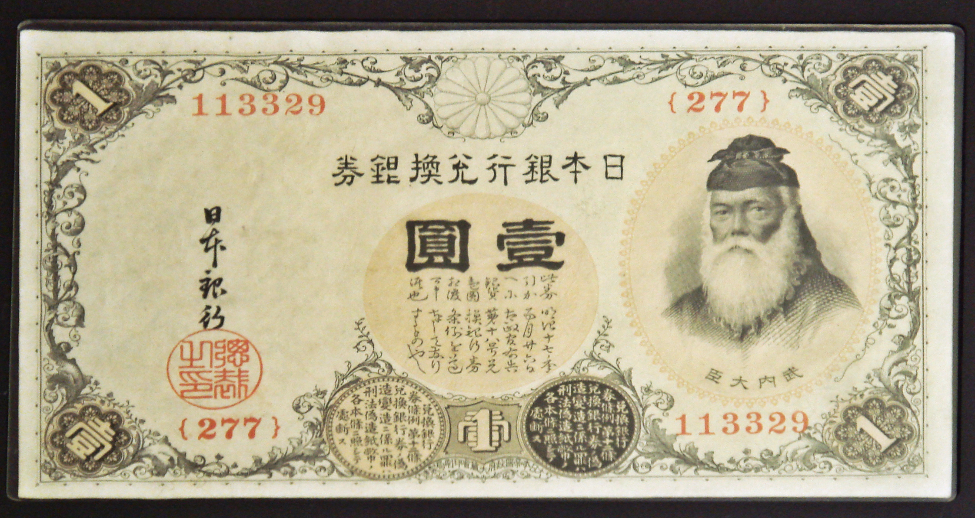](https://www.google.com/url?sa=i&rct=j&q=&esrc=s&source=images&cd=&cad=rja&uact=8&ved=0CAcQjRw&url=https://en.wikipedia.org/wiki/Japanese_currency&ei=HyChVcygNNa1yASo957QDQ&bvm=bv.97653015,d.cGU&psig=AFQjCNESiOKhcf_P_kHQiWA_e6qh1GUd_Q&ust=1436709250957348)Japan

$1 USD = 122.43 Japanese Yen

You will take $450.00 U.S. dollars for food and souvenirs. Exchange them for the currency of the country you are visiting.

How much Yen will you have when you convert your currency to spend in food and souvenirs while visiting the country of Japan?